Membership in the Czech Mountaineering Association – Český horolezecký svaz (ČHS)

basic information for foreigners

The Czech Mountaineering Association unites people who are interested in mountaineering, rock climbing, ice-climbing, dry-tooling as well as ski-mountaineering. The association is opened to all keen climbers regardless a country of origin.

A foreigner can also become a member of ČHS as an individual member as well as a member of a mountaineering club. For mountaineering club, , the consent of the club´s chairman is required.
Proof of membership is the ČHS card, which you will receive in an e-mail attachment confirming your payment and also by post. The ČHS card is valid from January the 1st until January 31st of the following year.

Membership fee for 2022
- children and youth up to 18 (born 2004 and later) – 100 CZK
- juniors age 19 – 25 (born 2003 – 1997) – 500 CZK
- adults age 26 – 65 (born 1996 – 1957) – 600 CZK
- seniors 66 years and old (born 1956 and earlier) – 200 CZK

Memberhip fee for juniors, adults and senior includes liability insurance valid pro the Czech republic.
To order your membership please use the e-shop, payments by debet / credit cards or e-banking https://www.horosvaz.cz/shop/
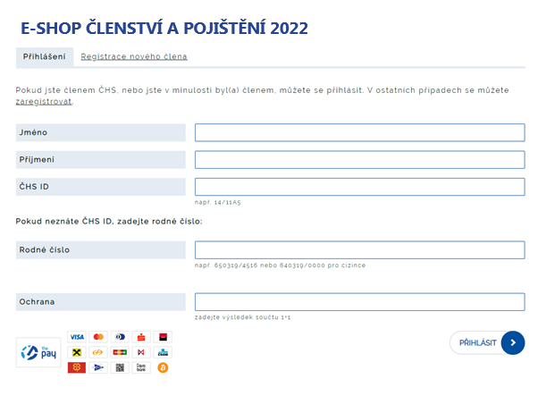

When registering, it is necessary to type your first and last name; do not fill in ČHS ID.
It is necessary to fill in also your date of birth – Rodné číslo - in the following form:
the last two digits of the year of birth, the two digits of the month of birth, the two digits of the day of birth, a slash, followed by another three or four digits, dependent on the year of birth. For foreigners, there are four zeros behind the slash.
Examples:
MEN
3.4.1964, birth number: 640403/0000
12.12.2020, birth number: 201212/0000
WOMEN
For women, for the third digit of the birth number replace 0 with a 5 (for births in January - September) or replace 1 with a 6 (for births in October - December)
3.4.1964, birth number: 645403/0000
12.12.2020, birth number: 206212/0000

Type 2 in Ochrana.

Your membership card can also be collected from the ČHS office during office hours following a cash payment.

For more information contact ČHS office: ivana.travnikova@horosvaz.cz

