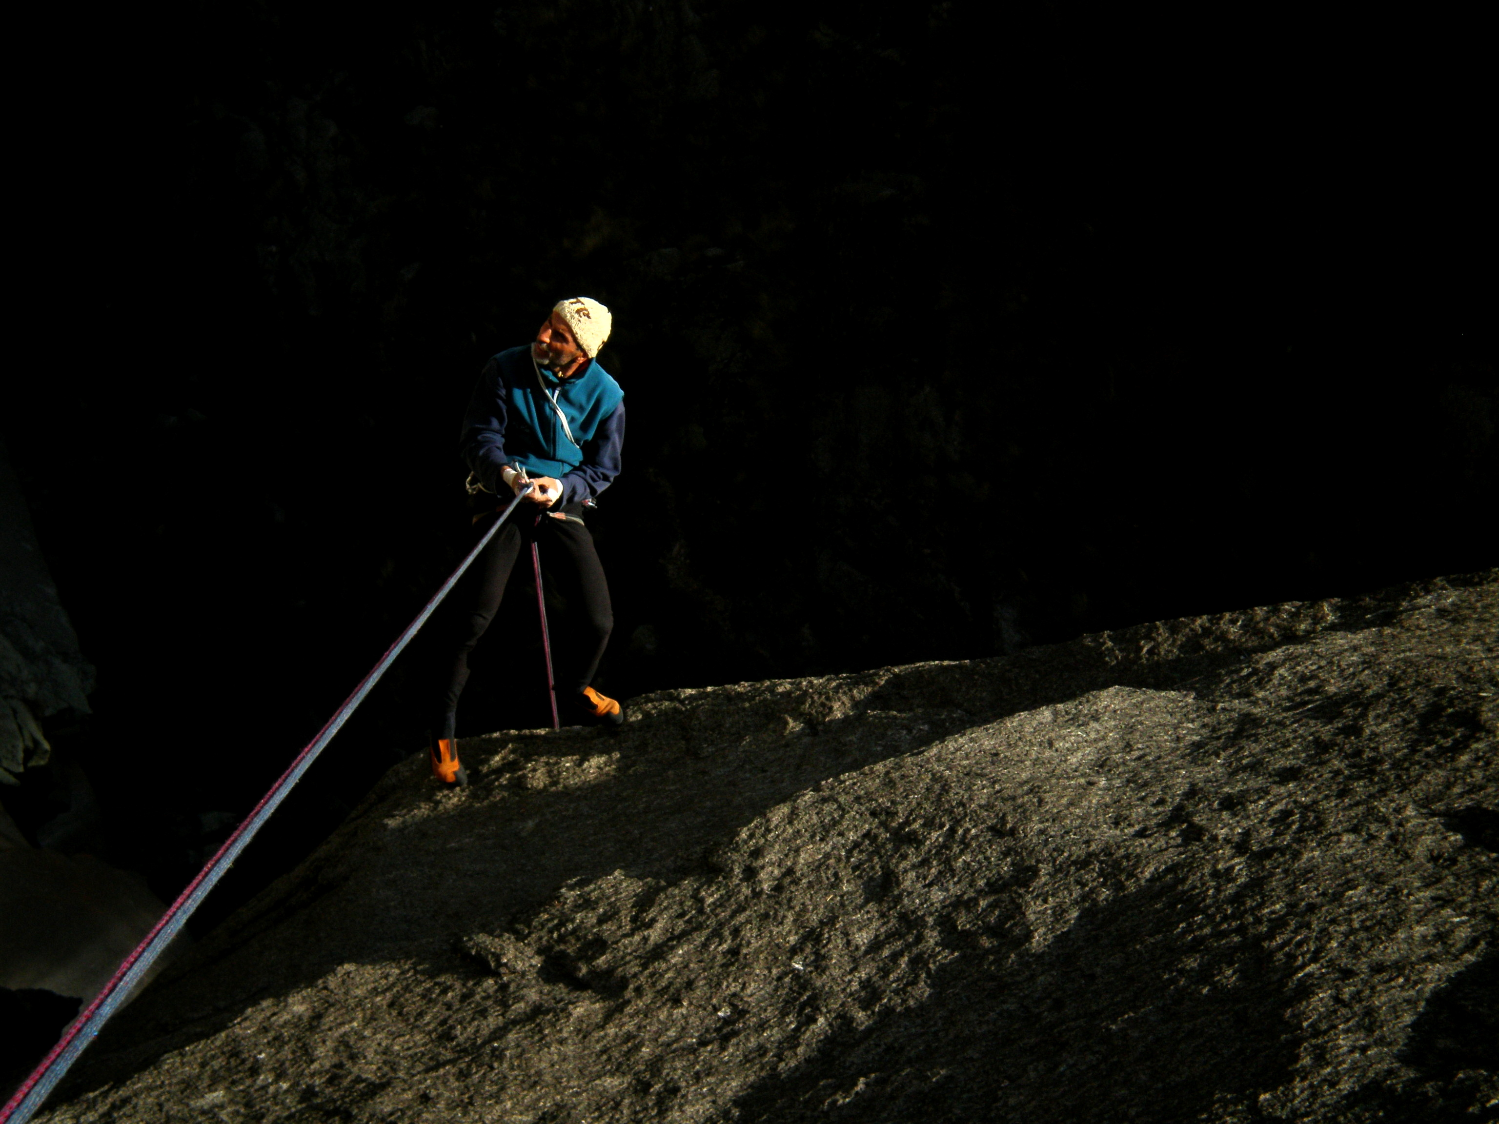
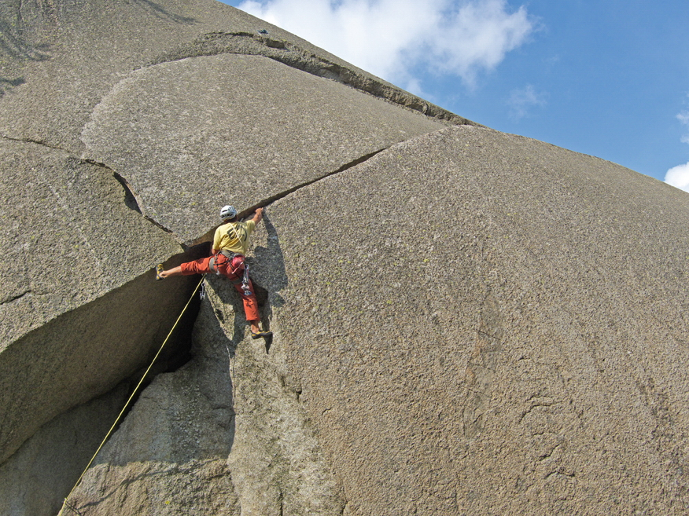
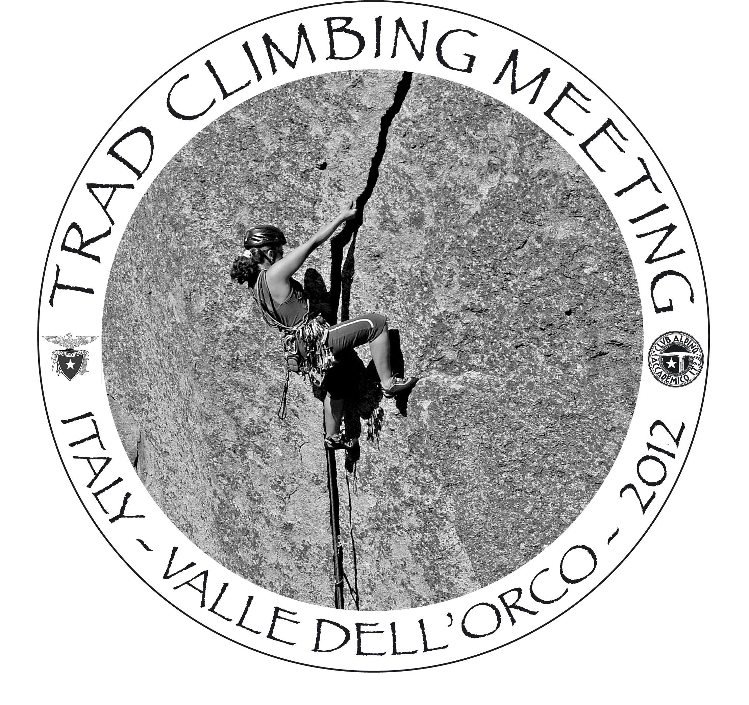
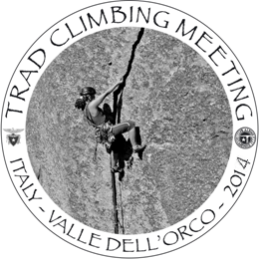
3rd INTERNATIONAL TRAD CLIMBING MEET
VALLE DELL'ORCO - ITALY
15-21 SEPTEMBER 2014

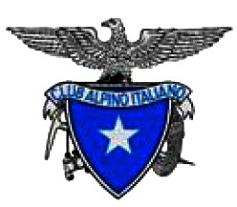
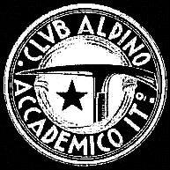

Club Alpino Accademico Italiano

Club Alpino Italiano

December 2013

TRAD CLIMBING MEETING – PRELIMINARY INFORMATION

Dear Sirs,

After the First and Second International Trad Climbing Meetings, held in Italy in September 2010 and 2012, we are here again. The concept of a meeting every second year seemed a viable compromise preserving on one hand the health of the organisers, while giving on the other hand a reasonable continuity to this important event.
Although with a slight delay on schedule, we are working for another wonderful climbing meeting in 2014.

Therefore we are pleased to invite your climbing federation to nominate two climbers from your country to take part in the Third International “Trad” Climbing Meeting, under organisation by the Club Alpino Accademico Italiano (CAAI, national section of Club Alpino Italiano).

The meeting will take place in Valle Orco, Western Alps (province of Torino), from the 15th to the 21st of September 2014. This valley is an historic place for the development of modern climbing in Italy. Climbing style is typical of granite, with face and crack climbing. “Trad” climbing skill is required on many routes, though face climbs generally have fixed gear.
Climbs are mostly multipitch adventures, either close to the road or requiring a longer mountain approach, with routes up to 500 meters in length, but in general not exceeding 200 meters. This is a unique area, where “Sport” and “Trad” climbing can still be practised with full enjoyment in a quiet and unspoilt alpine atmosphere.

CAAI will welcome the participation of both male and female representatives (a 50/50 share would be the best, but so far we were far away from this share). Each climber should be able to lead 5.10, E2, or french 6b, in order to get a reasonable personal satisfaction. Participants will be paired up with local host climbers with experience of the valley. Food and accommodation will be provided by the organisation during the whole meeting. Assistance in transfer from main airports and railway stations will hopefully be possible. Participants will only have to pay a registration fee of 100 Euro upon acceptance.

Draft programme overview:
Sunday 14.09 – Climbers arrival. Opening ceremonies in Ceresole Reale (Valle Orco) by 7pm
Monday 15.09 – Climbing day, evening slideshow on historic and modern climbs in the area.
Tuesday 16.09 – Climbing day
Wednesday 17.09 – Climbing day, evening slideshow.
Thursday 18.09 – Climbing day
Friday 19.09 – Climbing day, open to other participants
Saturday 20.09 – Climbing day, open to other participants. Evening Party
Sunday 21.09 – Closing ceremonies. Transfer to airports

The number of foreign participants will be limited to a maximum of 40. Thus you are kindly advised to apply well in advance. As soon as organisation details are finalised, further communication will follow (namely within April 2014).
A higher chance of participation will be given to early applicants

Further information will be available on www.tradclimbing.it from mid-January 2014
Inquiries and applications by e-mail: penasa58@gmail.com
Contact: Mauro Penasa (mobile: +39 348 8862343)
3rd INTERNATIONAL TRAD CLIMBING MEETING
VALLE ORCO 2014

SEPTEMBER 15-21, 2014

APPLICATION FORM

Please print, fill in, scan and e-mail to penasa58@gmail.com

First Name

Second Name

Nationality

Date of birth

Address

Climbing Federation

Climbing level (sport/trad distinction useful)

Means of travel (airplane, train or car)

Contact e-mail

Contact mobile phone

Other

NOTES:
A deadline is not applicable yet.
A second detailed informative with final deadlines will be circulated within April 2014.
100 Euro Registration fee due upon communication of acceptance
Travel arrangements to be taken upon communication of acceptance.

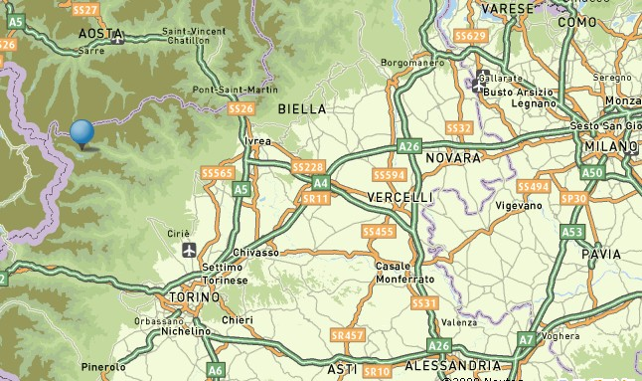
CERESOLE REALE

TRN
MXP
75 min travel
150 min travel
Two international airports may be used: Torino Caselle (TRN) and Milano Malpensa (MXP)
For train connections Torino Porta Nuova / Porta Susa stations
Individual/pool pick-ups will be organised according to participants travel plans.

