

French Alpine Club FEDERATION - Toulouse
* YOUTH COMMISSION

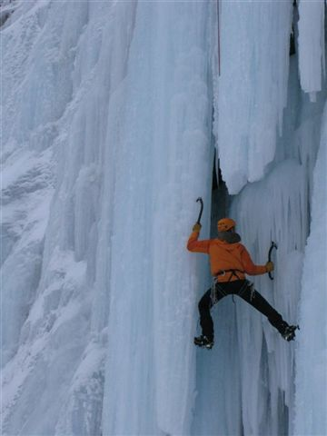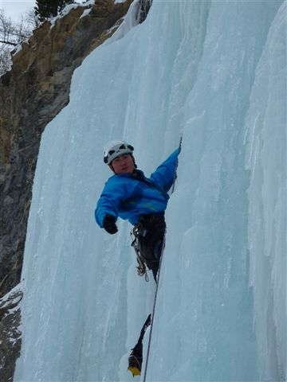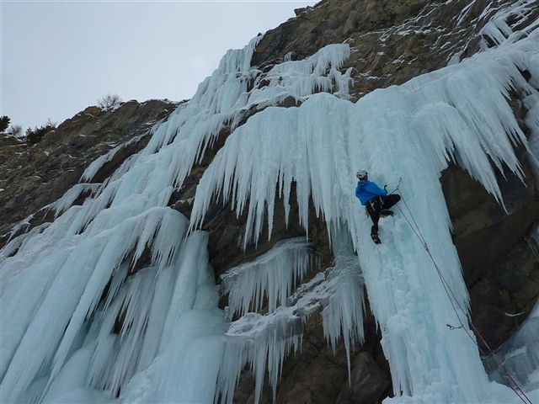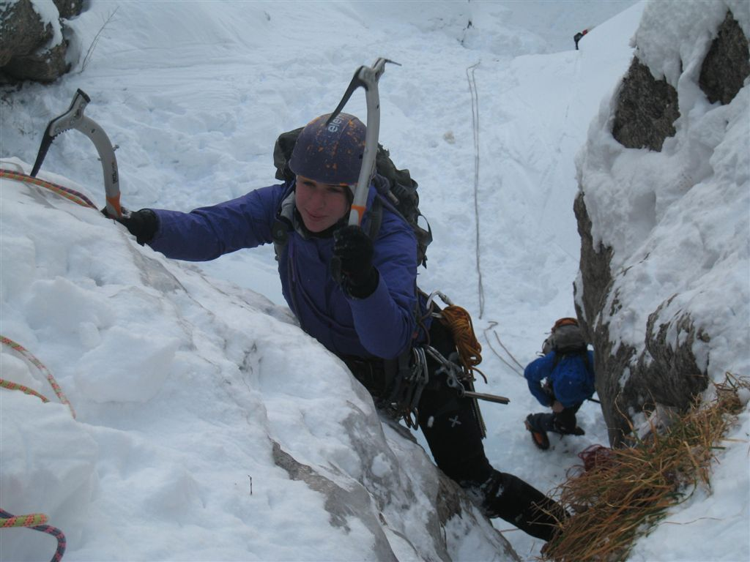

INTERNATIONAL YOUTH ICE CLIMBING CAMP
Guillestre, Hautes Alpes (05), France
03 - 09 March 2013

The main goal of this youth ice climbing camp is to learn practicing many forms of ice climbing, one pitch, or routes with many pitches.

Date: 03 – 09 march 2013.

Place: In Guillestre, near Briançon in south alp of france (region Rhones Alpes, departement 05, “Hautes Alpes)
This is the same location of the international Ice Climbing event of L’argentière la bessée.
All the ice climbing sites are described o this internet site: http://www.ice-fall.com/

Accommodation and Food: We will be in the Youth gite, called “Auberge des 4 vents” http://www.lesquatrevents.eu/ ) // tel: + 33 4.92.45.04.32 / Mail : aj.guillestre@free.fr
Rooms for 4 people, breakfeast and dinner are provided by the gite and are included in price.

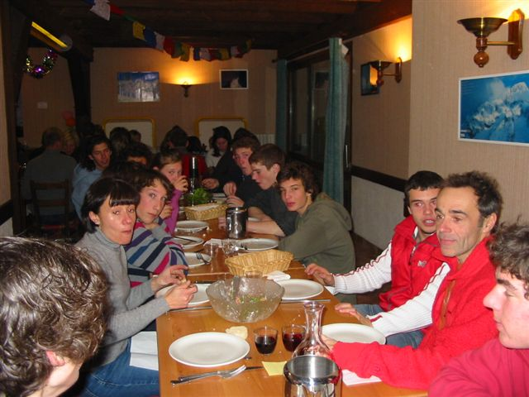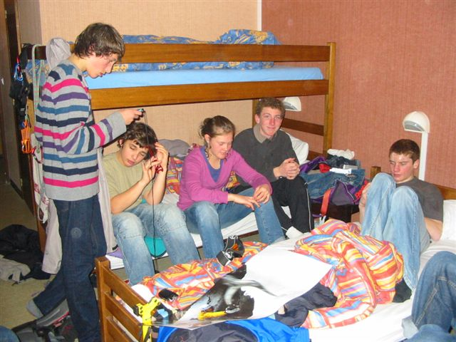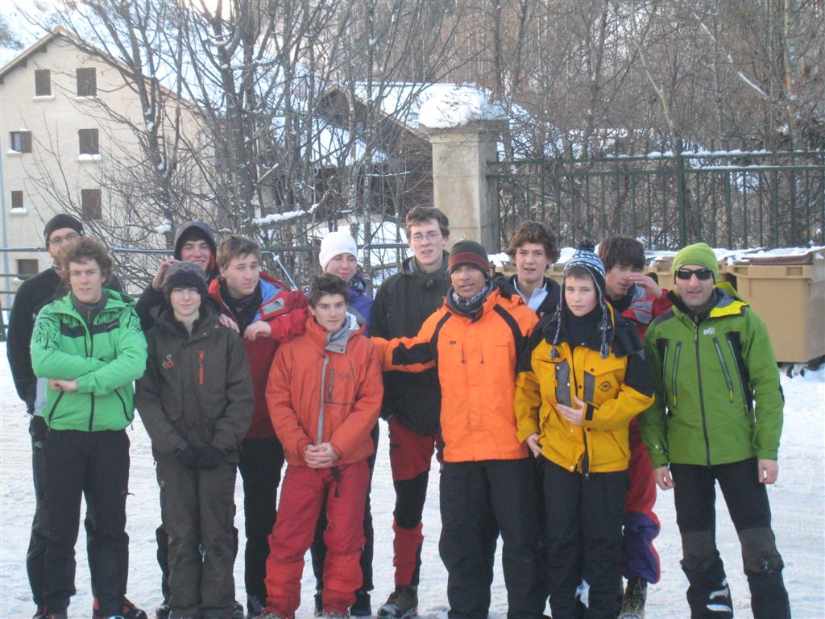

Staff / leaders: all the staff are qualified to supervise this event; instructors Alpinism.

Participants: Young people from 16 to 22 years old. Participants should lead climb at a minimum of 5b French grade, and should be autonomus for managing belay. We will be offering places to maximum of 4 participants per country Federation.
Participants younger than 18 years old must be accompanied by an adult Climber/coach, who is able to look after them during this meet.

Equipment: climbing harness, winter alpinism shoes with ice crampons, climbing helmet, belay device and 05 quick draws (UIAA standard/CEN), 2 ice axes (could be rented by staff), one detector device of avalanche (could be rented by staff), 05 ice screws, sun glasses & cream, sleeping bag, head torch, winter climbing clothing and wash kit, water bottle, any personal medication.

Insurance: Participants should get themselves insurance for accident, rescue, third party liability and travel which is valid for participating in the programme of climbing and trekking. This cover note of insurance should be presented to the organisers on arrival.

Entry visas: If your representatives need to obtain entry visa, please confirm their names and passport numbers to the contact emails as soon as possible as Visa processing is a very lengthy process.

Price: 230 EUR per participant, payable on arrival to the organiser. Accommodation, full board, leading and organisational costs included (except pic nic of mid day) .

Registration deadline: 15 of february 2013.

Meeting point:
- Gite
- Bus station of Briançon, on Saturday afternoon, the 01th of january 2012, about 6 PM. Please contact C Biard about arrival hours
- There is a train beetwen Briançon and Gap, with a stop at Montdauphin and then a shuttle to the gite “Auberge les 4 vents” .

*Transport: The easier to joign the meeting point is:
- to land at the international airport of Lyon St Exupéry,
- and then to take a bus from airport to grenoble
- http://www.lyonaeroports.com/fre/Accueil/Acces-et-parking/Quel-transport-choisir/Bus
- http://www.faurevercors.fr/LR_SATOBUS_en.html
- and then a second bus from Greboble to Briançon
- http://www.vfd.fr/horaires/ler-35/ler-35-horaires-ete
It is also possible to joign Grenoble from the airport of Genève (http://www.aerocar.fr/en/ )

Additional information and registration: Christian.biard@orange.fr
Member of the National Commissions of Youth and Mountaineering of FFCAM
Member of the Pyrenees Regional Committee
Head of Mountaineering and Youth sections at CAF-Toulouse

About UIAA Global Youth Summit events: These events are a great opportunity to meet a varied group of young climbers from home and abroad, and make new friends, as well as exchange climbing techniques.

Schedule / activities:
The main goal of this youth climbing camp is to practice many forms of ice climbing, one pitch, or routes with many pitches; all the ice climbing sites are described on this link: http://www.ice-fall.com/
- Some pictures of different events / camps on http://picasaweb.google.fr/bibiaussonne
http://picasaweb.google.com/bibiaussonne/2010_12GlaceGuillestre18Au23Dec2010Light#
https://plus.google.com/photos/118172597905435580242/albums?banner=pwa#photos/118172597905435580242/albums
- http://theuiaa.org/news_348_French-Alpine-club-holds-Global-Youth-Summit-ice-climbing-camp

Sunday, end of afternoom, 03 th of march 2013: Arrival about 18 PM of the participants coming from toulouse at the gite; catching in Briançon bus station of the foreigners participants ..
Installation in rooms and provisionning by staff of missing materials.

Others days : 07:00, breakfast, then spliting in groups according climber’s current level of ice climbing on differents sites.

Last day, Saturday, the 09 th of march 2013, about 1 PM: end of the camp (come back in Toulouse about 08 PM for people from toulouse).
REGISTRATION FORM
International ice climbing in Guillestre, Hautes Alpes (05), France
March, 03 to 09 of 2013.

FEDERATION: _________________________________________________

address: _____________________________________________________

Phone: _______________________ Fax: _________________________

E-mail: ______________________________

PARTICIPANT:
Name and Family Name |  |  |  |  |  |  |  |  | Sex
Date of Birth |  |  | Email
Address
Telephone |  |  | Fax
Mobile telephone
Emergency home contact number
Passport number |  |  |  | Period of validity
Date of issuing and city
Please indicate your language preferences.
Spoken languages | 1. |  |  |  |  |  | 2.
Special diets: ◻ vegetarian ◻ Eat variety ◻ allergies and intolerances ◻ special diet

Details:
Do you have any Special medical needs or allergies that we should be aware of?

Name and telephone numbers of a person we can contact in the event of an emergency
Participant climbing experience, level and skills:
I can tie in /Yes/No/ =
* I can top rope belay safely /Yes/No/ = using (belay device)
* I can lead belay safely /Yes/No/ with a (belay device)
My current on sight level is:________ My current red point level is:_______
If you have more participants, please use another copy of this form.
Place, date and time of arrival and transport, which you plan to use : (Briançon)
- By bus in Briançon (05)
_______________________________________________________________
Questions: ______________________________________________________

Name, surname, telephone, fax and e- mail of the person to contact:

________________________________________________________________

Date: __________ Signature____________________________

***Insurance: Participants should have a collective or individual insurance policy, which guaranties covering the expenses of the rescue operations if an accident happens to them in France. In addition third party liability, accident and travel insurance should be acquired. Please bring a copy of your insurance with you.
Name of the insurance company: ________________________________________
Policy number: ______________________________________________________
Others notes: ______________________________________________________

Participants applying for a UIAA Global Youth Summit event also acknowledge and accept that:
- Safety is a primary concern at UIAA Global Youth Summit Events, but as with all the other forms of climbing there is a danger of personal injury or death.
- Participants at UIAA Global Youth Summit events, and their parents if U18, accept the risks of participation and are responsible for their own actions, which should take account of relevant circumstances such as changing weather conditions.
- To take part it is necessary to be medically fit to do the activity and have valid liability and accident insurance which is valid in the country of the event and which covers rescue and repatriation. Please bring a copy of your insurance with you to show the organizers
Signed:(Participant)____________________________Date:___________

Please send this registration form through
Club Alpin Français de TOULOUSE , 3 rue de l'Orient - 31000 TOULOUSE France
Attention to C BIARD, Youth Commission*
before ending 15 february 2013.
Contacts
Club Alpin Français de TOULOUSE , 3 rue de l'Orient - 31000 TOULOUSE France .: 05-61-63-74-42
Fax : 05-61-63-96-60 / clubalpintoulouse@wanadoo.fr / http://clubalpintoulouse.fr/
Christian BIARD christian.biard@orange.fr / christian.biard@orange.com / + 33 682 33 86 63

Location of the site of the camp
*Transport: The easier to joign the meeting point is:
- to land at the international airport of Lyon St Exupéry,
- and then to take a bus from airpot to grenoble
- http://www.lyonaeroports.com/fre/Accueil/Acces-et-parking/Quel-transport-choisir/Bus
- http://www.faurevercors.fr/LR_SATOBUS_en.html
- and then a second bus from Greboble to Briançon
- http://www.vfd.fr/horaires/ler-35/ler-35-horaires-ete

It is also possible to joign Grenoble from the airport of Genève (http://www.aerocar.fr/en/ )

Meeting point: Bus station of Briançon, on Saturday afternoon, the 17th of december 2011, about 6 PM. Please contact C Biard about arrival hours (there is a train beetwen Briançon and Gap, with a stop at Montdauphin and then a shuttle to the gite “Auberge les 4 vents” .

