
UIAA Youth Commission  Global Youth Summit 2011 | Ukrainian Mountaineering  and Climbing Federation

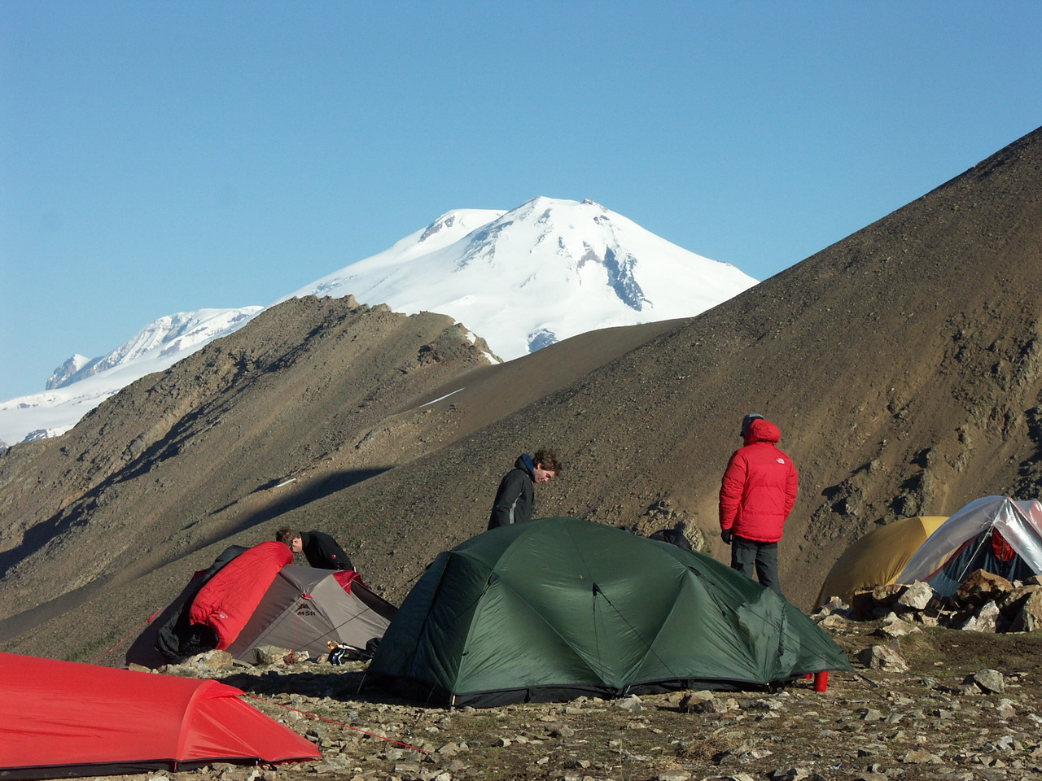
Welcome
to
the Caucasus!

“Mt.ELBRUS – 2011”
International Youth Expedition
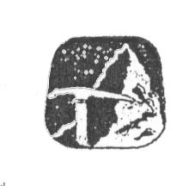


Dear Friends!

Mountaineers from Ukraine invite you to participate in the joint ascent to the highest peak of the Caucasus and Europe - Mt. Elbrus (5642m.) in summer 2011.

Grand Elbrus massive is situated slightly to the North from the main Caucasus Range, right in the central of the Caucasus. It is covered with ice and over than 20 glaciers start from there.

To climb of Mt. Elbrus is a dream of many mountaineers. The gorgeous panoramic view from the top of this mountain is the souvenir climbers take with them and remember all their lives.

The ascent is not technically difficult in summer. It does not require either deep knowledge or wide experience in using mountaineering techniques. However low temperature, severe winds, possible bad weather demand courage and strong will power from the climbers. Acclimatization training is necessary before an ascent to Mt. Elbrus. This training helps climbers adjust to the altitude.

To conduct annual join expedition to this marvelous region and to invite climbers from all over the world to participate in this event became a wonderful tradition of Ukrainian mountaineers.

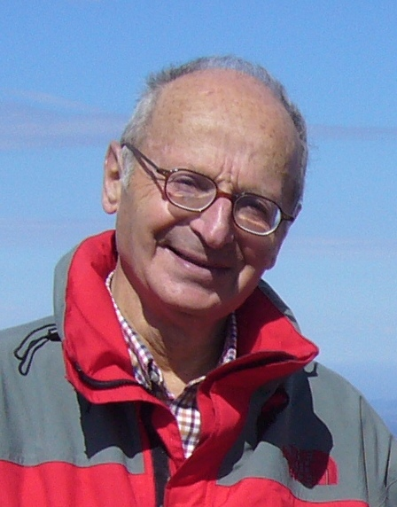 | Good Luck to All of You!  Alexander Zaidler

ITINERARY

Time: 5th of July – 16th of July, 2011 (12 days)
Place: the Central Caucasus, Kabardino-Balcaria region, Russia.
Age of Participants: 18 – 30 years.
Place of Arrival: International Airport of Mineralny Vody, Russia
Base Camp Camp “OCHAG” (2200 m) in Adilsu valley near Mt.Elbrus
Transfers: bus transfer (160 km) from Airport to base camp and then
according to the program
Accommodation: tents, or in houses for additional payment.
Route to Mt.Elbrus from the Southern side of Mt.Elbrus from Baksan River valley
Expedition Conditions: it is possible for any healthy person to make an ascent to Mt.Elbrus. However it is necessary to have experience of mountain travel and lodging in tents. It is desirable to have also experience of hiking using crampons. This ascent to the altitude of 5642m requires long walk in crampons, possibly with low temperatures, strong wind and cloudy conditions.
It is possible to do ski touring.
Meals: meals will be provided in a base camp (in a canteen) and the participants will be equipped with food products for cooking themselves during the ascents. However, participants are free to bring special products that they are used to eating at high altitude.
Equipment: The information on necessary clothes, equipment etc. is provided
in the document “Additional Information” to follow.
Insurance: Every participant must have an appropriate insurance valid for the period of the expedition
Price: 330 Euro
This price includes: The invitation to Russia, meeting at the airport, accommodation in the basic camp, meals, acclimatization training, route consultations, registration in Russia fees and permit for entering the border zone.
This price does not include: transport from airport Mineralny Vody to a base camp and back, other transport expenses (the estimated sum for transfers is Euro 90), taxes of National Park “Prielbrusye” and cable way tickets to the slope of Mt.Elbrus (3900m) (approximately Euro 45), private excursions, expenses for phone calls etc.

Additional information: is compiled in a separate document which will be sent to all
participants of the expedition after their registration.

Deadline of applications: 15.05.2011.

If you have any questions, please contact us via e-mail: a_zaidler@yahoo.com

PROGRAM

O5.07 Arrival. Bus transfer from Mineralny Vody airport to a base camp in Adylsu valley. Meeting the participants. Accommodation in tents

06.07 Rise to a panoramic view point. Introduction to the area.
General meeting of the participants

07.07 Acclimatization walking tour. Training on glacier.

08.07 Leaving for acclimatization ascent. Overnight stay at the 3500m altitude

09.07 Acclimatization ascent to the top about 4000m. Overnight stay.

10.07 Return to a base camp. Preparation for the ascent to Mt.Elbrus.

11.07 Leaving base camp for Mt. Elbrus. Rise with cable-way. Setting altitude camp (4200 m).

12.07 Acclimatization climbing up to 4800 m.

13.07 Ascent to the West Peak of Mt. Elbrus, 5642 m.

14.07 Back up day in case of bad weather. Return to a base camp.

15.07 Preparation for departure. Farewell party.

16.07 Transfer to Mineralny Vody. Departure from Mineralny Vody airport.

APPLICATION FORM

Participation in the expedition “Mt. ELBRUS - 2011” from 05.07.11 till 16.07.11
A. About Mountaineering Federation (Association or Club):
Mountaineering Federation or Club):
Name of federation contact person:
Telephone:
Mobile:
Email:
B. Brief information about the participants
Name, Surname | Sex | Address,  Telephone Number,  E-mail Address | Citizenship | Date of Birth | Passport Details  (number,  valid till_)
C. More information about participants to be completed by participants:
Any special food requirements e.g. vegetarian:
Describe your mountaineering: courses, mountains climbed:
Name and telephone numbers of a person we can contact in the event of an emergency
D. Participation agreement:
For an activity to be adventurous it must have an uncertain outcome and it will carry risks. Going into mountainous regions on expedition is implicitly hazardous, and adding that to an adventurous activity, then by necessity the hazards are increased. This implies an inherent and intractable risk of injury or, in the extreme, death. Anyone considering taking part in an expedition needs to consider this very seriously and to take responsibly for their own participation.
Expeditions are fascinating and exciting, not just because of the mountains we visit, but because of the parts of the world we go to. This alone is an important incentive to go but it means some regions have limited infrastructure. If you are injured, problems with infrastructure alone can mean a delayed evacuation and so a worse medical outcome than for a similar accident nearer to home. In order to take part in a truly exciting, adventurous activity with all the rewards of experiencing diverse cultures and sharing unforgettable memories with newly found friends, you have to accept the risks involved.
N.B. If you have some participants, please use another copy of this form.
Participants should have a collective or individual insurance policy, which guaranties covering the expenses of the rescue operations if an accident happens to them in the Caucasus. In addition third party liability, accident and travel insurance should be acquired. Please bring a copy of your insurance with you.
Name of the insurance company: ________________________________________
Policy number:______________________________________________________
Others notes: ______________________________________________________
Date: Signature:
This form must be sent to the following e-mail: a_zaidler@yahoo.com

