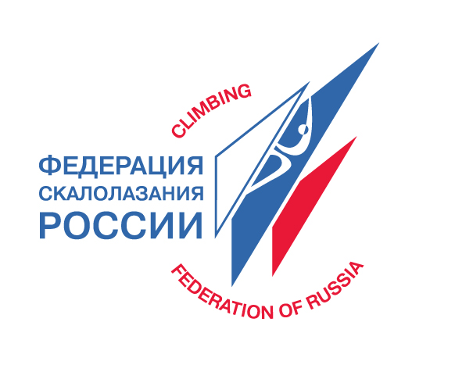



Information note

Rock Climbing Festival – Guamka 2010 Russia, Krasnodar Region, Guamka

9-15 August 2010

Climbing Federation of Russia is happy to invite you to participate in the International Rock Climbing Festival in Guamka (Krasnodar Region).

This area (Apsheronsk region) is located in Krasnodar Region on the north-east side of the Caucasus. The region is situated between the foothills of the Main Caucasus mountain range and the Black Sea, which means having favorable climate and natural beauty. The Apsheronsk region borders with Sochi region where the Olympic Games of 2014 will be held.

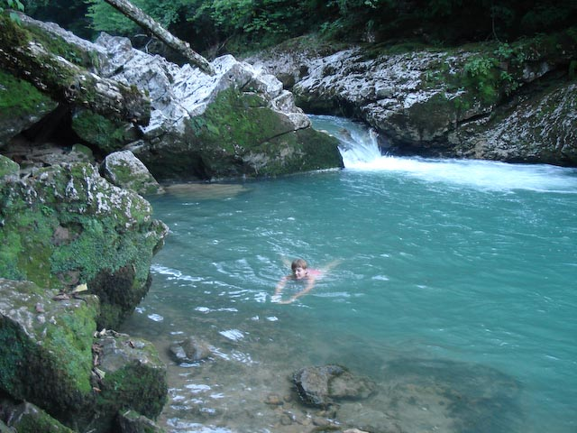
Natural beauty of this area attracts a great number of tourists and artists. You will come to a breathtaking place – plateau Lagonaki, where the snow doesn’t thaw till the middle of June. You will see unusual caves and the really fantastic Guamka Canyon and the Canyon of the river Kurdzhips. You will be impressed by the view of the waterfalls and grotto and unique natural vegetation –ancient forests and water-meadows.
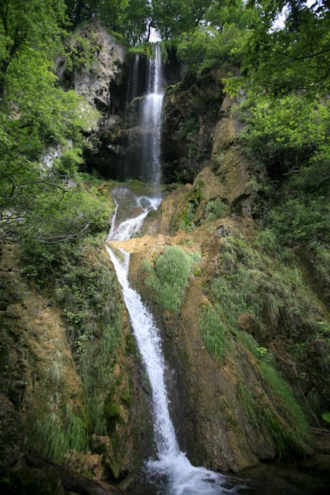

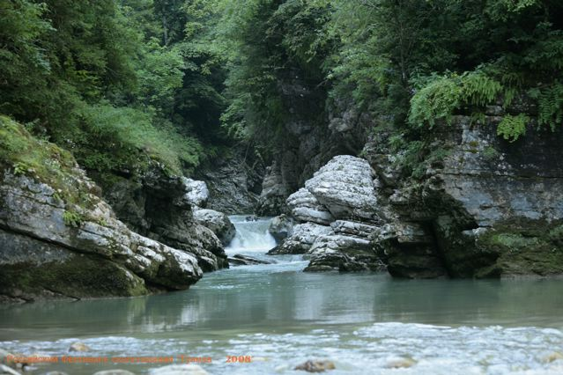

Guamka Canyon is 8 km long. There is a tourist path along the edge of the Canyon and the café has a verandah with a marvelous view of the rocks in the central part of the canyon. There are rocks on each side of the canyon.

The quality and the number of climbing routes in Guamka can allow the sport climbers of different levels to climb and train there. Specially prepared and well-equipped routes are in 15-40 minutes’ walk from the village. You can come and climb during the Festival and you have the opportunity to compete if you wish. There are friendly competitions for veterans, children, top climbers and amateurs in lead climbing, pair-linked climbing and speed climbing. There will be a competition for guests on the specially prepared leap routes
The 128 routes in 9 sectors (4b-8b+ level of difficulty) have already been prepared.
50-60 new routes will be ready for the beginning of the Festival.
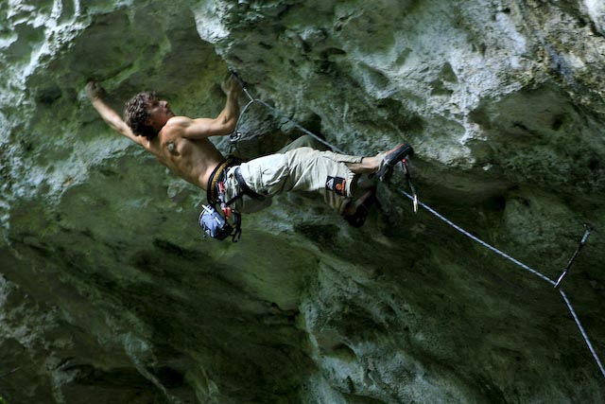
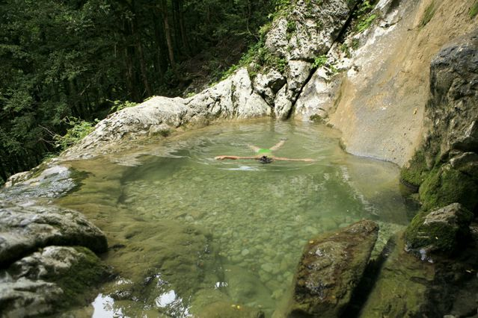

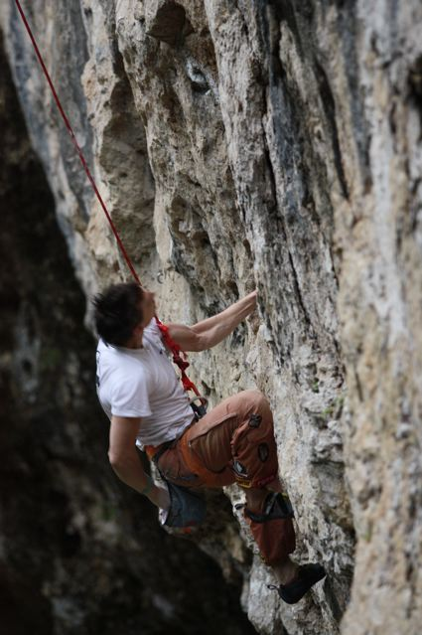
.

The cultural program of the Festival includes film, music, dancing, slide-shows, and entertainment for children, fireworks and other fun events for all our guests.

The camping will be located on the bank of the river Kurdzhips in the beautiful village, where you can find three new comfortable hotels with nice cafés and restaurants, saunas and billiards. There is a little lake, a spring of fresh water, a playground and different places for rest times.
Last year (2009) we had an experience of organizing this Festival in Guamka and we can say that the experience was really successful and attracted a lot of people, who climbed, competed and had a good time!

This year you will have a chance not only to take part in the competition program, but also admire wonderful nature, have a lot of positive emotions and meet new friends!
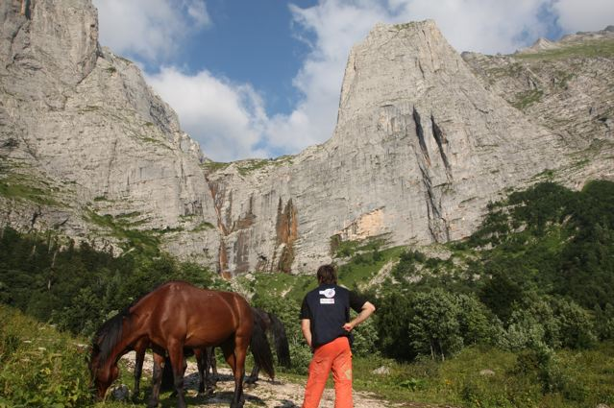
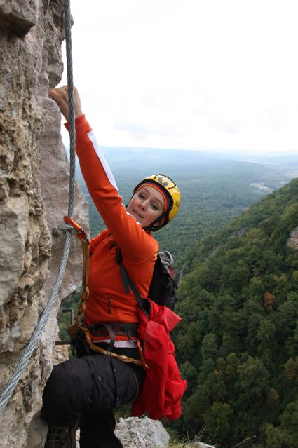

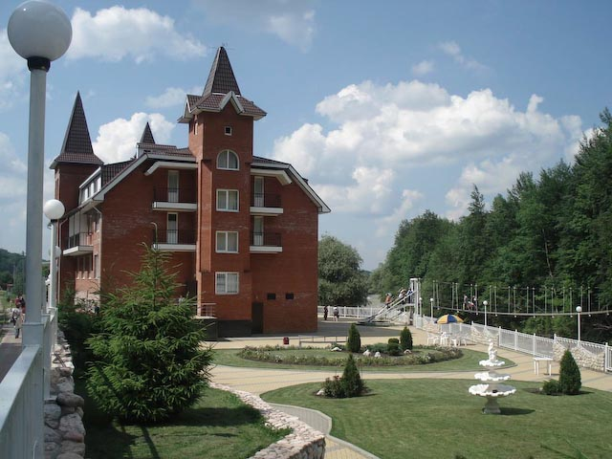

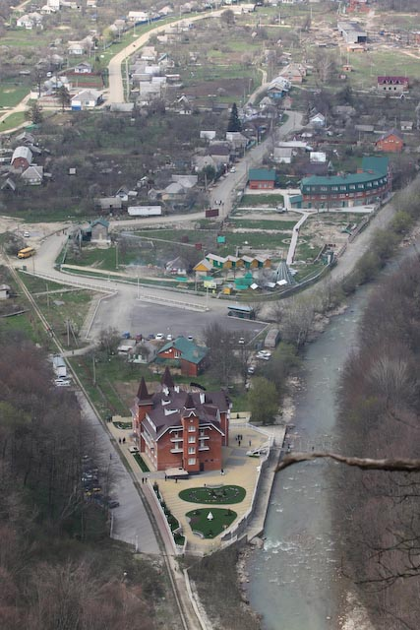
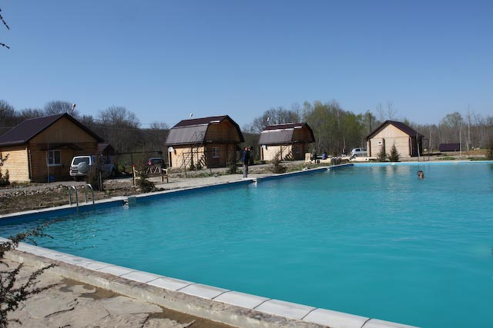
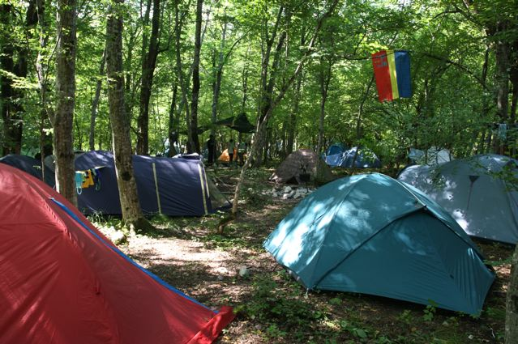
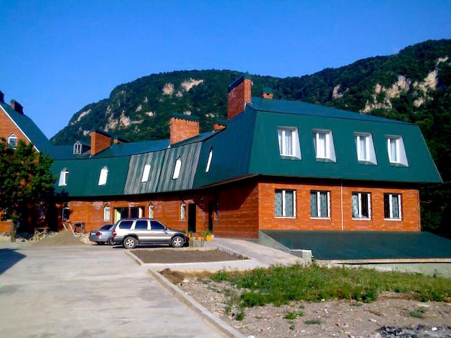

We really look forward to seeing you in Guamka!

Objectives:
- International exchange of experience and relevant information
- Increasing knowledge of rock climbing safety for the participants
- Making rock climbing more well known and popular in the region
- Promoting a healthy lifestyle – a way of life

Organization:
General supervision and organization of preparing and conducting the Festival is realized by Ministry of sport, tourism and youth politic of Russia, Climbing Federation of Russia and Krasnodar Region.

Program:
The program of the Festival includes the following disciplines: difficulty route climbing, pair linked climbing, difficult climbing with time (the final). All the guests and the participants of the festival will have an opportunity to participate in the additional program of the festival, which will include trekking to Plateau Lagonaki, canyoning, Via-ferrata, a zip wire, a trip to the western side of mount Fisht, where some multi pitch routes are located and a trip to the sea. It is possible to join the festival for climbing with out entering the competition too.

9 August (Monday) – Arrival, accommodation of the participants and the visitors of the Festival, registration of the participants (till 8.00 p.m.). Technical meeting with the jury.

10 August (Tuesday) – Grand opening of the climbing festival, climbing and competition program.

11-14 August - Climbing programme, Competition programme.

15 August (Sunday) – The Final (pair linked climbing, difficult climbing with time).
Award ceremony. Closing. Departure. (One extra day in case of bad weather).

The program of the competition will be defined more exactly and can be changed on site depending on the situation with weather, participants and other.

The participants: The participants are subdivided into the following groups (men and women, boys and girls):

* Children – 12 years old and younger
* Teenagers – 13-16 years old
* Veterans – 1 (aged 50 – 59)
* Veterans – 2 (aged 60 and older)
* Adults – amateurs
* Adults-sportsmen
* Beginners (Participants and visitors of the festival regardless of age, who have never climbed before).
Participants under 18 are allowed to take part in the competition by the Letter of Attorney written in a free form from their parents to the adult representative. (App 1) Any participants under 18 must be accompanied to Russia and throughout the festival by their climbing parent/coach or Federation representative.

Regulations:
In difficult climbing routes the participants will be offered 100 routes with a top rope and lead belay.

The participants provide their safety themselves (they belay each other on the routes), so they must have appropriate skills of dealing with belaying and they must also have their own equipment ( a helmet, a harness, a rope, quick draws, a belay device) that corresponds to the requirements of UIAA.
A number of attempts on routes are not limited. All routes, except the competition final are open.

Only finished routes are taken into account. The participants are ranked according to the sum of points for the finished routes. The value of the i- route is calculated in points Ci and expressed by a formula:

Ci = N-ni+(N/ni),

N – total number of the participants(men and women regardless of the group).
ni – a number of participants, finished the i-routes.
The final of the most difficult climbing routes are organized as difficulty climbing with a time limit. In other words, those who finished the route are ranked according to the time spent climbing, the others – according to the height they manage to climb. 8 men and 8 women with best results from all the groups reach the final.
For all who wish (except children and beginners) there is an opportunity to participate in pair linked climbing. The competition includes two rounds (qualification, final) with judges top rope belay in two groups: men and women. Mixed (a man + a woman) pair linked climbing is included in a man group.
The groups of teenagers and veterans will have a separate final. The rules of difficult climbing routes and an approximate list of essential equipment will be introduced later.
Competitions for the beginners will be held on special routes.
Speed climbing competition will be organized on the artificial climbing wall and will include two rounds: qualification and final.

Scoring:
1 Individual, separate for men and women (girls and boys) in each group in each discipline (except pair linked climbing).
2 Team. The team (with a name) is formed at the event by the participants. The team consists of three men and two women. The result is based on the sum of rating points.

The organizers are entitled to make changes in these regulations.

Prizes:
The winners and the prize-winners of the Festival in each group are rewarded with diplomas and valuable presents from the partners and the sponsors of the festival. The prize-winners of the team competitions are rewarded with diplomas.

Dates: 9-15 August 2010

Place:
Village Guamka, Krasnodar Region (in the south of Russia).
Nearest airport:
- Sochi (260km)
- Krasnodar (160 km)
- Rostov-na-Donu (370 km)
On the advance requests there can be organized a transfer from airport to the place of destination.
Also it is possible to ride from Moscow by train:
Moscow -Camping – free of charge, sleeping in tents. All necessary things for staying must be provided by the participants and the guests. For cooking food it is necessary to have special equipment (gas-stoves, burners, primus stoves). Belorechensk station: price for ticket is 30€. There will be a free bus from Belorechensk to Guamka from organizers of Festival.

Accommodation options:
- Camping is located in a nice wooded area, on the river bank and it is 20 minutes walk to rocks. There is a games area and a little lake at the camping.
- Hotels in Guamka: If you would prefer to stay in a hotel with your young climbers the prices start at 20€ person/day. Participants have the option to pay to stay in hotels or use the free camping

Food:
It is possible to have meals in a cafe or to prepare your own independently in the camping. In village there are some cafe and grocery shops. You are expected to provide and pay for your own food during the Festival. We can help you with buying it from the shops. For young participants the leader from your country will help you arrange and cook your food.

Entry visas:
By your request we send the invitation for the visa to Russia up until 30 days before the event.
The invitation can be sent an e-mail or a fax, and also the original mail letter (necessary for making the visa request in a Russian Embassy/consulate in your country).
Invitation cost for the letter from the organizers agent - 10€.
Visa cost to Russia (for the countries of Shengen) - 35€. This may vary according to the rules of the country that you are applying from. Check your foreign office website and the site of the Russian Embassy/Consulate in your country. Visas to Russia can also be arranged by reputable travel agencies which offer this specific service.

Insurance:
Participants should get themselves insurance for accident, rescue, third party liability and travel which is valid for participating in the program of climbing and other events in Russia.
This cover note of insurance should be presented to the organizers on arrival.

Visa invitation and travel arrangements
For requests hotels, transfers, invitation to Russia and other additional information please send the request to climblife@yandex.ru.

Applications:
Deadline for the application (App2) is 30 June (inclusive)
The address is al_scala@hotmail.com
It is possible to apply to the secretariat in Guamka on the 9 August till 8p.m.
(Those who will arrive later will have an opportunity to register and participate in the competition program after the main start).
All the participants must have the following documents with them: an identity card (passport), participants under 18 must have the Letter of Attorney (parental consent to take part in the activity) from their parents held by the adult Federation or club representative who is accompanying them to the Festival.
Individual application fee is 20 Euro or 700 rubles. Groups (children, teenagers and veterans) – 10 euro or 300 rubles

Contacts:
Svetlana Sdobnikova (Organizer of the Festival) – e-mail- <sdobnikova_sv@mail.ru>
Maria Sdobnikova ( visa, accommodation,transfer) – +7926-585-4630 e-mail msdobnikova@yandex.ru
Office Climbing federetion of Russia (CFR) – e-mal info@c-f-r.ru, www.c-f-r.ru, +7925 5178722

APPLICATION FOR participation in “Rock Climbing Festival – Guamka 2010”
9-15 August 2010

- About Mountaineering Federation (Association or Club):
Mountaineering Federation or Club & address:
Name of federation contact person:
Telephone & Fax: | Mobile: | Email
- Brief information about the participant (submit 1 form per participant)
Name and Family Name |  |  |  |  |  |  | Sex
Date of Birth |  | Email
Address
Telephone |  | Mobile telephone
Passport number |  |  | Period of validity
Date of issuing and city
Spoken languages | 1. |  |  |  | 2.
Special diets: ◻ vegetarian ◻ Eat variety ◻ allergies and intolerances ◻ special diet
Any Special medical needs or allergies we should be aware of?

C. More information about participants to be completed by participants and/or their leaders if U18:
Name and telephone numbers of a person we can contact in the event of an emergency
Participant climbing experience, level and skills:
I can tie in Yes/No * I can top rope belay safely Yes/No * I can lead belay safely Yes/No * I have climbed multi pitch? Yes/No * Please circle Yes or No
My current onsight level is: My current red point level is:
Crags, climbing areas visited, number of years climbing:
I can swim 25m? Yes/No. Please circle Yes or No.

Letter of Consent from CFR
Any participant who is under 18 year old must be accompanied by a Federation or Club leader. Any under 18 year old participants must have parental consent

I_(full name)___________ , (passport number )_ ____ _________give permission to my son/daughter (full name)_________________ _(date of birth)_____________, (passport number) ____________________, to take part in the Rock-climbing Festival – Guamka 2010 (Krasnodar region) in August 9-15, 2010. I have been informed of the regulations of the Festival. I entrust the safety of my son/daughter to (full name)___________ , (passport number)___________________
I have read and understand the programme information.

Signed (Parent/Guardian): Date:__________________

Participants and their parents (if U18) applying for a UIAA Global Youth Summit event also acknowledge and accept that:
- Safety is a primary concern at UIAA Global Youth Summit Events, but as with all the other forms of climbing there is a danger of personal injury or death;
- Participants at UIAA Global Youth Summit events, and their parents if U18, accept the risks of participation and are responsible for their own actions, which should take account of relevant circumstances such as changing weather conditions.
- To take part it is necessary to be medically fit to do the activity and have valid liability, accident rescue and travel insurance as above.

Signed (Participant)_________________________________________Date:______________________

Signed (Parent/Guardian) – if participant is under 18: Date:__________________

Applications:
Deadline for the application (App2) is 30 June (inclusive)
The address to send applications is al_scala@hotmail.com
It is possible to apply to the secretariat in Guamka on the 9 August till 8pm. (Those who will arrive later will have an opportunity to register and participate in the competition program after the main start).

Appendix 2

To the Main Board of Judges of
The Final of Rock climbing Festival in Russia “Guamka 2010”
(Krasnodar region)
from ______________________________________________________
(sending organization, address , telephone, е–mail)
________________________________________________________

Team Application Form

for participation in the competition
We are asking for admission to participation in competition for the team/Federation_______________________________________ consisting of
(name of the team)
№ | Full name of the participant | Age (date of birth) |  |  | Signature of the participant(proved the awareness of safety rules) | Notes
1.
2.
3.
4.
5.
6.
Other participants
7.
8.

Admitted to the competition ____ sportsmen. Not admitted to competition____ including ______________________________

Team representative ‘ Club Federation leader___________________________________________________________________________________________________
Full name ,address, telephone, е–mail
is aware of safety rules ______________________( _________________________________________________________ )
representative’s signature and surname
Team captain_________________________________________________________________________________________________________
Full name ,address, telephone, е–mail

