
CLIMBING & HIKING IN BICAZ GORGES NATIONAL PARK

INTERNATIONAL YOUTH CAMP IN ROMANIAN CARPATHIANS

August 7-15, 2010

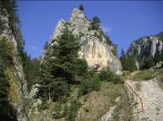
Location: A climbing paradise in a superb natural landscape and a traditional rural ambiance. Near the impressive Red Lake, in the famous deep gorges sculptured in Mesozoic limestone rocks there are over 200 climbing routes, bolted or classic, UIAA grade 3 to 10, 1 to 15 pitches, 15m to 300m high. Access and way down are short and easy. The first route (grade 4) was established in 1934 on the elegant Altar Tower. The area was designated a natural park and the climbing (free, artificial or mixed), hiking and trekking here are unique.

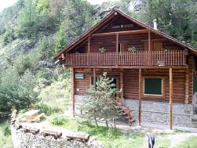
Accommodation and Board: The ECOLOG Hut (‘Cabana Ecolog’), alt. 700m, good conditions, full-board. The hut is a new mountain base and is run by staff of the Romanian Mountain Club. There is no need for tents, mats or stoves. Your own sleeping bag is not a must. If you are a vegetarian please let us know in advance. Int’l telephone, e-mail and Internet access available at the hut.

Management and coaching: there will be a camp director (not a bad guy, don’t worry) and experienced qualified instructors. You are expected to give a hand and assist with organization.

Local transportation and transfers: Provided by us (minibus, 4 WD).

Programme: at least 4 days climbing & hiking, 1 day mountain walking/hiking/climbing (Ceahlau Mt. natural park, alt.1907m), 1 day (optional) cultural round trip to the city of Piatra Neamt (capital of Neamt county), Moldavian mediaeval monasteries, Bistrita valley and the 40 km long Bicaz Lake. Still new routes potential, all grades. Optional: mountain-biking, caving, horse-riding, boat-fishing, swimming.

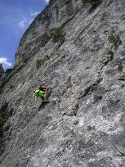
Indoor and near camp activities: Exchange of experience, discussions and seminars on mountain tourism, access and conservation, climbing techniques, specific top issues in different countries. Slide-shows, videos, expeditions presentations, songs, dancing, campfire & barbecues. You’re welcome to present your slides / videos!

Participants: All levels climbers and hikers aged 17 to 25. Either for the beginner or for the toughest and most experienced climber, there are choices for everyone. You’ll be asked in advance about your experience and outdoor preferences in order to balance the programme to your needs and to make-up the climbing / hiking teams. Personal health & travel insurance is required.
Participants younger than 18 years have to have an accompanying person who is responsible for the young participant. The accompanying person must obtain parental consent for their participation.

Equipment: Technical gear, clothes and shoes for rock climbing and summer mountain trekking (15 to 28 Celsius and possible rain or hot sun). Don’t forget headlamps and helmets. Climbing gear shopping point at the hut.
Costs: EUR 250, - per participant for the entire programme, accommodation, full board and local transport.

Arrival: Participants should arrive at the hut on August 7th. The Ecolog Hut is located in the Carpathian Mountains, in the NE Romania, Neamt county, Bicaz-Chei village. The nearest towns are Gheorghieni (34km West) and Bicaz (24km East), linked by national road DN 12-c which crosses the East Carpathians. The 200m
path to the hut starts from the small parking at Km 34 (sign to the hut!). We can pick you up from various railway or bus stations (Bicaz - 24Km, Piatra Neamt - 50Km, Gheorghieni - 34Km or Bacau - 110Km). If you fly to Bucharest (400Km South), we could assist your transfer by bus or train.

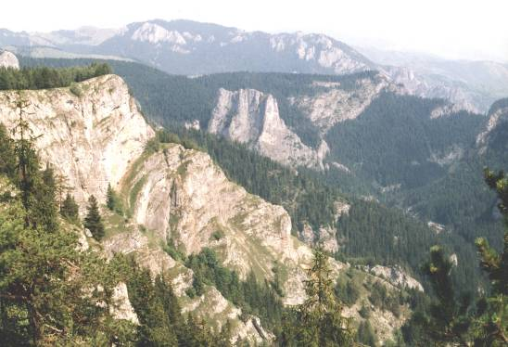

Departure: August 15, after breakfast. Transfers arranged to the bus, railway stations or airports.

Registration and Info: Please fill in and send us the Registration form attached until July 10, 2010. You’ll get full details after the registration. For more info please contact:

All participants under 18 must be accompanied by an adult/team leader over 18 when travelling to an event as specified. We expect parental consent to be obtained by participating Federation for anyone under 18 years.

*Bring a copy of health and travel insurance certificate, plus passport copy.

ROMANIAN MOUNTAIN CLUB: mountain.romania@gmail.com , office@mountain.ro
Constantin Lacatusu (camp director): lacatusu8850@yahoo.com,
Tel / fax: +40.233.222 222;
Mobile: +40.744.913 941.

Registration form

Youth Climbing and Hiking Camp - Carpathian Mountains–

7-15 August 2010
Please send this registration form to:
Romanian Mountain Club: tel/fax: +40.233.222 222;
e-mail: mountain.romania@gmail.com; office@mountain.ro
or Constantin Lacatusu (Camp director) e-mail: lacatusu8850@yahoo.com

1. FEDERATION/CLUB INFORMATION - FILL IN 1 FORM PER PARTICIPANT
Alpine Association
Address:
Fax:
Email
Tel.
Name of contact person:

2. PARTICIPANT INFORMATION
Name: Age:
Address:

Phone MOBILE: Phone HOME:

Fax: E-mail:

Accompanying person NAME (IF UNDER 18 YEARS)
Person who can be contacted in the event of an emergency:
Tel:
 | Passport number |  | Period of validity

3. TRAVEL
Place, time of arrival and means of transport which you plan to use. If flying include flight number, arrival time and airport: We’ll arrive by: train plane car

Arrival in Place:
Date & Time:
Flight number if applicable:

Departure Place:
Date & Time:
Flight number if applicable:

4. INSURANCE
Type of insurance cover which you have e.g. travel and personal accident, including rescue and name federation or company that the insurance is with, including policy number:
Bring a copy of your insurance cover note with you

5. OTHER
Spoken languages | 1. | 2.
Special diets: ◻ vegetarian ◻ Eat variety ◻ allergies and intolerances ◻ special diet
Details:
Do you have any Special medical needs or allergies that we should be aware of?

More information about participants to be completed by participants and/or their leaders if U18:
Participant climbing experience, level and skills:

I can tie in Yes/No * I can top rope belay safely Yes/No * I can lead belay safely Yes/No * I have climbed multi pitch? Yes/No* Please circle Yes or No.

My current onsight level is: My current red point level is:
Please describe your mountaineering experience until now (courses, climbed mountains, current lead climbing standard)

PARENTAL CONSENT for under 18 year olds only:
- I confirm I am the parent/guardian of the above named child and that I consent for him/her to take part in the UIAA Global Youth Summit, ‘CLIMBING & HIKING IN BICAZ GORGES NATIONAL PARK’
- Safety is a primary concern to the organsing Federation, but as with all forms of climbing I confirm that I am aware there is a danger of personal injury or death and that I am responsible for providing appropriate personal safety equipment for the above named child to undertake this event.
- I have read the event programme and understand the nature of this activity. To take part it is necessary to be medically fit and have valid liability and accident insurance.

Signed (parent or guardian only): .................................................... … Date ………………………….

Signed (accompanying leader): ……………………………………….. Date ………………………….

Questions:

Participant Signature: ________________________ Name: _____________________

Leader Signature: ________________________ Name: _____________________

Date_____________

