"... When Prometheus was chained to the rocks of the Caucasus, set out his old enemy Dragon to destroy the hero. But it was told: not to be Prometheus at the mercy of Dragon. And was turned Dragon into the stone on the slopes of Kazbek and became Dragon Rocks..."



MOUNTAINEERING & CLIMBING ASSOCIATION of GEORGIA
CLUB MOUNTAIN TRAVELLER

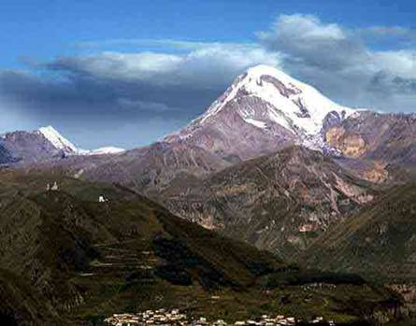
On behalf of the Mountaineering & Climbing Association of Georgia the Club Mountain Traveller (CMT) is pleased to invite the young members of the UIAA associations to the international youth "Mountaineering School" in Georgia.

Date:

10-17 July (exact dates may be changed by 1-2 days depending on flight availability but any changes will be displayed as soon as possible)

Place: Kazbek Gorge mountains– Georgia

Accommodation: Tents and meteorological station at 3600m

Boarding: Full board and lunch bag for ascent

Management: Experienced instructors from the Mountaineering & Climbing Association of Georgia

Participants: Young people aged 16 years and over. If under 18 to be accompanied by a qualified federation leader. Parental consent must be obtained for under 18’s be the sending Federation who is responsible for the young participant.

Costs: 250 EUR for 8 days for the entire program, payment on arrival. For those who wish a bank transfer is possible

Equipment: Mountain clothes for high altitude, cold and windy weather including: boots, sleeping bag, ice axe, helmet, harness, crampons, sun glasses, gloves, navigation equipment/GPS etc. Contact us if you need more advice on equipment and you can also ask your federations advice.

Meeting point: July 10th Tbilisi, in front of state Post office on Rustaveli avenue, 12⁰⁰ local time (exact dates may be changed in 1-2 days depending on flight availability in July 2010).

Departure: July 10th, 2010 in Tbilisi

Registration term: Ending June 25, 2010

Information and Registration: Zurab Kutchava
Mountaineering & Climbing Association of Georgia
Club Mountain Traveller
6 K. Meskhi by-street, Tbilisi, Georgia, 0108
tel.: +995 99 502368, +995 32 93533, email: zkutch@yahoo.com, clubtravell@hotmail.com

KAZBEK GORGE MOUNTAINS
GEORGIA, 10-17 July, 2010

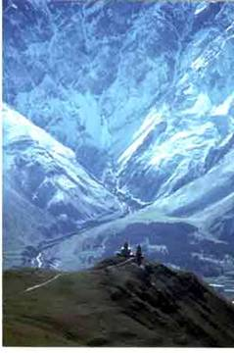
Kazbek (5047m), one of the highest and beautiful peaks in the Caucasus, is situated in the eastern part of the central Caucasus, in Georgia. The Mount Kazbek Region contains itself a lot of summits over 4000 meters and is one of the most important mountaineering and trekking areas in the Caucasus. Mt. Kazbek is also known as “Mkinvartsveri”- by its Georgian name. The first ascent on Kazbek was fulfilled in 1868 by D. Freshfield.
The summit Kazbek represents a surprising number of ancient legends and sights. Approximately at the altitude 3800 m. on 80 -m rocky wall in a cave there is an ancient monastery Betlemi (Vifleem). Under the ancient Georgian annals "Kartlis Skhovreba ", this monastery holds stonehouse relics and church treasures. According to information, sacred Josef, who rose to the monastery, presented queen Irakli a tablet of stone from the house of Abraham. In ancient centuries the monks climbed up the weighed ferrous circuit. The ancient legend described by famous Georgian poet Ilia Chavchavadze in a known poet and connected to the monastery: A falling shepherdess of the sacred monk sheltered there after having lost the path - and as punishment for the fall, by god's will the monastery on the summit Kazbek was set up. One other ancient legend of the rocks of Kazbek Prometheus was arrested. The old enemy, Dragon, heard about it and was set to pay with the hero, but was converted into a rock and formed Dragon's Rocks deposited at the altitude of 4800 m. in a large 1km horseshoe. By main ornament Khevi (the gorge Darial) and its numeral is a monastery Sacred Trinity – on Georgian Sameba, where one time there was a Cross of sacred Nino. The monastery is picturesque placed against a background of Kazbek, is direct above town Kazbegi. And at the altitude approximately 3900m. There is a modern small church.
The way from Tbilisi to Kazbegi Region lies through the beautiful Aragvi Valley and Jvari Pass (2380m). This trip takes 3,5 hours. After we get to a small town Kazbegi (1700m) we begin our slope up to the Camp 1 (2950m). This is a delightful trek across the alpine pastures leading us to the Gergeti Glacier. From the campsite we pass a moraine and continue our trek crossing the glacier. We reach the high mountain refuge - Meteorological station (3600m), situated on the south slopes of Mount Kazbek.
Kazbek is diverse landscape also for the climber and from a tourist point of view. The classic path to the summit is estimated by 2-d category of complexity according to the scales and is fine for those who make an ascent of a accents 5,000m peak for the first time. Directly from the meteorological station to the summit there is an ice-stepped route of 3-d category of complexity. In winter 2003 the members of Club Mountain Traveller made the first ascent of a 5-th category route on Dragon's Rocks wall.
In spite of the technical ease of its classic route, Kazbek is a serious mountain. Although not a great deal of advance mountaineering experience is required for the ascent on Kazbek, you will need to be familiar with the basic use of crampons and ice axes and you should be in good physical condition. We have only a few days for acclimatization before we ascent the summit. We do not do any rock climbing, although the final sections of the mountain will be climbed on icy slopes at about 20-30 degrees and the ropes will be fixed for more safety and ease of climbing. Please note that helicopter rescue is not necessarily possible on Kazbek. Participants must have rescue and repatriation insurance cover which is valid for Georgia.

Plan:

1st day (most probably on July 10)
Arrival of the participants at the Tbilisi in front of state Post office on Rustaveli avenue, 12⁰⁰ a.m. local time. Meeting with leaders.
The participants from Tbilisi arrive in the settlement Kazbek and travel through the Aragvi Valley and Jvari Pass (3.5 – 4 hrs) to reach a small town Kazbegi (1700m).

2nd day:
The participants climb up to the first camp approximately 2700m height.

3rd day
Rise of the participants to the meteorological station at 3600m height.

4th day
Acclimatization trek on height 4200м, those who wish ascend Ortsveri (1-st category of complexity) is possible. Decent to meteostation.

5th day
Day of rest and preparation before ascent. It is possible for those who wish to visit the high-mountainous remote monastery "Betlemi" at approximately 3800м height. Probably, on a condition of the members of expedition, this day we go on height 4300m and make before storm high-altitude camp on a glacier, with observance of the appropriate rules of safety.

6th day
Summit day.
Depending on weather conditions the rearrangement of 5-th and 6-th days is possible.

7th day
Descent from meteorological station to the settlement Kazbek and trip to Tbilisi. Those who wish can leave though the Georgia- Russia border.

8th day
Leaving

- Please note that a location map and further meeting information will be provided on registration
- If your federations have any questions about the programme please let us know
- Please leave adequate time to receive a VISA

